Where we swim

Glass Mill Leisure Centre
41 Loampit Vale
Lewisham
London
SE13
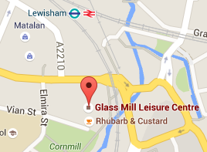
Tel: 0303 303 0111
Web: http://www.fusion-lifestyle.com/centres/Glass_Mill_Leisure_Centre

Downham Health and Leisure Centre
7-9 Moorside Road
Bromley
Kent
BR1 5EP
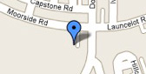
Tel: 0208 461 9200
Web: http://www.harpersfitness.co.uk/downham-health/

Wavelengths Leisure Centre
Giffin Street
Deptford
London
SE8 4RJ
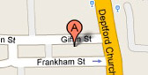
Tel: 0208 694 9400
Web: http://www.fusion-lifestyle.com/centres/Wavelengths_Leisure_Centre/Splash

Forest Hill Pools
Dartmouth Road
London
SE23 3HZ
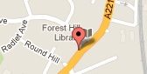
Tel: 0208 291 8730
Web: http://www.fusion-lifestyle.com/centres/Forest_Hill_Pools
CRYSTAL PALACE NATIONAL SPORTS Centre
National Sports Centre,
Ledrington Rd,
London
SE19 2BB
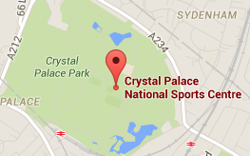
Tel: 020 8778 0131
Web: www.better.org.uk/venues/crystal-palace-national-sports-centre

